- PART 1 – GENERAL
  - References
    - All work shall conform to the latest revised codes and standards that having jurisdiction, including but not limited to:

      - ANSI / API 609, Lug and Wafer Type Butterfly Valves.

      - ANSI / ASME B16.1, Cast Iron Pipe Flanges and Flanged Fittings, Class 25, 125, 250 and 800.

      - ANSI / ASME B16.3, Malleable-Iron Threaded Fittings, Classes 150 and 300.

      - ANSI / ASME B16.5, Pipe Flanges and Flanged Fittings, Steel Nickel Alloy and other Special Alloys.

      - ANSI / ASME B16.9, Factory-Made Wrought Steel Buttwelding Fittings.

      - ANSI / ASME B16.18, Cast Copper Alloy Solder Joint Pressure Fittings.

      - ANSI / ASME B16.22, Wrought Copper and Copper-Alloy Solder Joint Pressure Fittings.

      - ANSI / ASME B16.25, Butt welding Ends.

      - ANSI / ASME B16.34, Valves – Flanged, Threaded and Welding Ends.

      - ANSI / ASME B18.2.2, Square and Hex Nuts.

      - ANSI / ASME B40.1, Pressure Gauges and Gauge attachments.

      - ANSI / ASME B40.2, Thermometers, Direct reading and Remote Reading.

      - ANSI / ASME Section VIII, Boiler and Pressure Vessel Code.

      - ANSI / AWWA C111 / A21.11, Rubber Gasket Joints for Ductile-Iron and Gray-Iron Pressure Pipe and Fittings.

      - ANSI B18.2.1, Square and Hex Bolts and Screws.

      - ASTM A47M, Specification for Ferritic Malleable Iron Castings.

      - ASTM A53, Specification for Pipe, Steel, Black and Hot-Dipped, Zinc Coated, Welded and Seamless.

      - ASTM A126, Specification for Gray Iron Castings for Valves, Flanges, and Pipe Fittings.

      - ASTM A167, Specification for Stainless and Heat-Resisting Chromium Nickel Steel Plate, Sheet and Strip.

      - ASTM A216 / A216M, Specification for Steel Castings, Carbon, Suitable for Fusion Welding for High-Temperature Service.

      - ASTM A276, Specification for Stainless and Heat-Resisting Steel Bars and Shapes.

      - ASTM A278, Specification for Grey Iron Castings for Pressure - Containing Parts for Temperatures up to 345°C.

      - ASTM A536, Specification for Ductile Iron Castings.

      - ASTM A351 / A351M, Specification for Steel Castings, Austenitic, for High-Temperature Service.

      - ASTM B62, Specification for Composition Bronze or Ounce Metal Castings.

      - ASTM E202, Test Method for Analysis of Ethylene Glycols and Propylene Glycols.

      - CAN / CGSB-14.4, Thermometers, Liquid-in-Glass, Self-Indicating, Commercial/Industrial Type.

      - CAN / CGSB-14.5, Thermometers, Liquid-in-Glass, Self-Indicating, Commercial / Industrial Type.

      - CSA B51, Boiler, Pressure Vessel, and Pressure Piping Code.

      - CSA B242, Groove and Shoulder Type Mechanical Pipe Couplings.

      - CSA W47.1, Certification of Companies for Fusion Welding of Steel.

      - CSA W47.1S1, Supplement No 1, Steel Fixed Offshore Structures, to W47.1.

      - MSS-SP-67, Butterfly Valves.

  - Submittals
    - Submit dimensional drawings and technical data in conformance with client’s instructions.

    - Submit pump curves showing the operating point, for verification.

    - Submit detailed wiring diagrams of control systems established by the manufacturer.

    - Submit heat exchanger performance conditions and other technical information.

  - Instruction and Maintenance Manual
    - Supply the required manuals and incorporate them into an “Instruction and Maintenance Manual”.

    - The maintenance manual will comprise of or indicate the following:

      - A description of the major components: the manufacturer’s series or model reference number, power rating, flow and pressure and/or capacity in BTU/h;

      - All details relating to the operation, care and maintenance of component;

      - A list of equivalent component replacements.

- PART 2 – PRODUCT
  - Heat Transfer Module

    - Module will be composed of [one] [two] pumps, heat exchanger, expansion tank, air separator, chemicals pot feeder, and glycol fill system (optional). Pre-assembling, testing and final adjusting at the factory, allows the module will be on-site ready for mechanical and electrical system connections.

      - Technical specification of the pumps selected maybe copied into this section:
________________________________________________________________________________________________________________________________________________________

      - Technical specification of the expansion tank selected maybe copied into this section:
_________________________________________________________________________________________________________________________________________________________

      - Technical specification of the glycol fill system selected maybe copied into this section:

_________________________________________________________________________________________________________________________________________________________

    - 880RI Vertical-in-Line Pump:
      - Volute: Cast Iron Class 30 (ASTM No. A 159), suction and discharge side flanged connections. Threaded connections for pressure gauges at the inlet and discharge flanges, for venting and draining, and for optional thermometer. A pitot tube type flowmeter, Flo Fab series IMF, can be supplied and installed on the discharge of the volute, taking differential pressure readings and confirming pump capacity. Incorporated in the volute casting is a solid base with four anchor holes and a connection to drain that can accommodate a valve with bronze cap, model HN0050. The volute includes a wear ring that is replaceable. Maximum operating pressure is 1200 kPa (175 psi).

      - Impeller: Cast Bronze (ASTM No. B 584), closed type, dynamically balanced, keyed to the stainless steel shaft and secured by a stainless steel bolt and washer.

      - Shaft: stainless steel, fitted with bronze sleeve and butane O-ring.

      - Sealing: The wet-end components are sealed with a self-lubricating mechanical seal. The seal is composed of a ceramic seat, a rotating carbon ring, a viton bellow and all other materials in stainless steel. It is designed for continuous operation at maximum working temperature of 400°F (205°C) corresponding to a maximum working pressure of 1724 kPa (250 psi).

      - Coupling: Pumps above 5HP - A flexible coupling of steel hubs and rubber sleeve between the pump and motor shaft located inside a “power frame”, permitting the servicing of the pump; mechanical seal, wear ring, impeller, without disturbing the piping connections.

      - Motor: respecting the requirements of Section 15010. Motor and pump are designed for vertical mounting. Motors equipped with grease lubricated heavy duty ball bearings, suitable for maximum loads created by the pump. Motor type TC, high-efficiency class B with a safety factor of 1.15 for series 880RI.

      - Selection of motor will allow the pump to operate at maximum capacity without surpassing the maximum amperage draw on the motor.

      - Each pump is hydrostatically tested.

      - Size and Capacity: As specified on pump tables shown on [plans] [specifications].

      - Acceptable component: Flo Fab series 880RI.
Alternative Pumps

    - Closed Couple Horizontal End Suction Pumps

      - Pump Flo Fab series 1000 are stand alone closed coupled pumps, single stage, with end suction volute that can be supported. Servicing of the pump can be performed without disturbing the piping connections.

      - Volute: Cast Iron Class 30 (ASTM No. A 159) without foot support. Threaded connections for a pressure gauge at the discharge end, as well as for venting and draining. The volute will be provided with a replaceable wear ring.

      - Impeller: Cast Bronze (ASTM No. B 584), closed type, dynamically balanced, keyed to the stainless steel shaft and secured by a stainless steel bolt and washer.

      - Coupling: No coupling design, impeller is directly coupled to the motor shaft.

      - The wet-end components are sealed with a self-lubricating mechanical seal. The seal is composed of a ceramic seat, a rotating carbon ring, a viton bellow and all other materials in stainless steel. It is designed for continuous operation at maximum working temperature of 400°F (205°C) corresponding to a maximum working pressure of 1724 kPa (250 psi). A replaceable bronze sleeve installed on the pump shaft, to protect the shaft from undue wear by the mechanical seal.

      - Pump designed for an operating pressure of [1200 kPa (175 psi)] [1724 kPa (250 psi)] [2068 kPa (300 psi)].

      - Motor: respecting the requirements of Section 15010, NEMA specifications, closed type, high efficiency, and foot mounted.

      - Selection of motor will allow the pump to operate at maximum capacity without surpassing the maximum amperage draw on the motor.

      - Each pump is hydrostatically tested.

      - Size and Capacity: As specified on pump tables shown on [plans] [specifications].

      - Acceptable component: Flo Fab series 1000.

Alternative Pumps

    - Bearing Frame Horizontal End Suction Pumps

      - Pump Flo Fab series 2000 are base mounted pumps with a flexible coupling, single stage, with non-foot mounted volute. Servicing of the pump without disturbing the piping connections.

      - Volute: Cast Iron Class 30 (ASTM No. A 159) without support. Threaded connections for a pressure gauge at the discharge end, as well as for venting and draining. The volute will be provided with a replaceable wear ring.

      - Impeller: Cast Bronze (ASTM No. B 584), closed type, dynamically balanced, keyed to the stainless steel shaft and secured by a stainless steel bolt and washer.

      - The wet-end components are sealed with a self-lubricating mechanical seal. The seal is composed of a ceramic seat, a rotating carbon ring, a viton bellow and all other materials in stainless steel. It is designed for continuous operation at maximum working temperature of 400°F (205°C) corresponding to a maximum working pressure of 1724 kPa (250 psi). A replaceable bronze sleeve installed on the pump shaft, to protect the shaft from undue wear by the mechanical seal.

      - Pump designed for an operating pressure of [1200 kPa (175 psi)] [1724 kPa (250 psi)] [2068 kPa (300 psi)].

      - Flexible coupling is used to transmit power from the motor to the pump. The coupling is designed for easy of disassembly, further allowing removal of the bearing housing and impeller without disturbing the alignment between the volute and motor. It will be able to absorb extreme torsional shock and vibration. A removable guard attached to the base will provide protection to maintenance personnel against the rotating coupling.

      - Motor and pump are factory pre-aligned but must be re-aligned after site installation and after base grouting.

      - Motor: respecting the requirements of Section 15010, NEMA specifications, closed type, high efficiency, and foot mounted.

      - Selection of motor will allow the pump to operate at maximum capacity without surpassing the maximum amperage draw on the motor.

      - Each pump is hydrostatically tested.

      - Size and Capacity: As specified on pump tables shown on [plans] [specifications].

      - Acceptable component: Flo Fab series 2000.

    - Plate and Frame Heat Exchanger [Steam-Water]:
      - General:

        - The heat exchanger is designed, constructed and tested in accordance with the requirements of the reference standards listed above.

        - The heat exchanger will carry the ASME seal of approval.

      - Frame: constructed with steel threaded rods and carbon steel side plates that is protected with a coat of enamel epoxy paint.

      - Maximum Operation Pressure: 1034kPa (150psi).

      - Maximum Service Temperature: 149°C (300°F).

      - Plates: 304SS, Herringbone pattern.

      - Gasketing: Rubber Nitrile.

      - The herringbone plates and gaskets are compressed between the two side plates thus providing the sealing of the heat exchanger. The alignment of plates will be provided by two lateral guide rails linked to the side plates. Further compression or release is provided by the lateral threaded rods.

      - Size and Capacity: As specified on heat exchanger selection tables.

      - Acceptable Components: Flo Fab series NT.

Alternative Heat Exchanger

    - Shell and Tube [Steam-Water]:
      - General:

        - Heating medium circulates within the shell and outside the tube bundle and transfers heat to medium circulating within the tubes bundle.

        - The heat exchanger is designed, constructed and tested in accordance with the requirements of the reference standards listed above.

        - The heat exchanger will carry the ASME seal of approval.

      - Shell: steel construction and pressure tested to 1MPa (145 psi), Flanged inlet and NPT outlet connections for sizes up to 12” and both flanged connections for larger sizes. Threaded couplings to receive a relief valve, pressure gauge, drain fitting and vacuum breaker.

      - Head: steel construction, threaded inlet and outlet connections for sizes up to 10” and flanged connections for larger sizes.

      - Maximum operating pressure: 1034 kPa (150 psi).

      - Maximum operating temperature: 190°C (375°F).

      - Tubes: DN ¾ exterior diameter, 304SS, with viton baffle supports.

      - Tube Sheet: Steel.

      - Fouling Factor: 0.0005 for steam and 0.001 for water.

      - Size and Capacity: As specified on heat exchanger selection tables.

      - Mounting brackets: steel saddles.

      - Acceptable Components: Flo Fab series S or W.

    - Expansion Tank:

      - An expansion tank with a replaceable bladder. A seamless carbon steel body covered with a layer of primer. Carbon steel construction coated with a layer of primer. Built according to ASME requirements for a maximum operating pressure of 862kPa (125 psi) and maximum operating temperature to 115ºC (240ºF). An isolation valve should be installed at the entrance of the tank.

      - Description:
Capacity: [____] L ([____] gal US)
Dimension: [____] mm Diameter x [____] mm High.
Dimension: [____] in Diameter x [____] in High.

      - Acceptable Components: Flo Fab series BT.

    - Air Separator:

      - Carbon steel construction coated with a layer of primer. Built according to ASME requirements for a maximum operating pressure of 1034 kPa (150 psi) and maximum operating temperature to 228ºC (550ºF).

      - Acceptable Components: Flo Fab series SEP.

    - Chemical Pot Feeder:

      - A chemical holding tank that is pressurized by the discharge header and will release chemicals into the suction header. A maximum operating pressure of 2068 kPa (300 psi) and temperature to 93ºC (200ºF).

    - Control Panel for [duplex] [triplex] system will consist of:

      - NEMA-1 (US) or EEMAC-1 (CANADA) enclosure;

      - Main disconnect;

      - Magnetic starters combined with fuses and fuse holders;

      - Overload protection on each phase equipped with an auxiliary contact NO and NC auxiliary contact;

      - Adjustable overload protection;

      - Secondary transformer circuit breakers;

      - 3 position selector switch «H-O-A» for each pump;

      - Pilot light indicators:

          - Power on
          - Run
          - Low Pressure
          - Surcharge

      - Adjustable low suction pressure switch to stop pumps.

    - Multi-Function Valves:

      - Diameters equal or greater than DN 2.

        - Epoxy coated cast iron body; all wetted brass parts shall be alloyed to resist dezincification. Grooved to 300lbs or flanged to 125lbs ANSI standard connections which can withstand a maximum working pressure of 1.7 MPa (250 psi) and a maximum service temperature of 121°C (250°F).

        - Each valve shall have a combination of three functions flow balancing, check, and shut off, with manual hand wheel adjustment and nameplate percentage reading.

      - Acceptable Components:

        - Globe Valve: Flo Fab series MFV

    - Suction Diffusers:
      - Cast iron construction Class 125. Maximum working pressure 1207 kPa (175 psi) and maximum working temperature 121°C (250°F).

      - Connection: Flanged Rating Class 125 ANSI flat face.

      - Suction Diffuser is a combination flow straightener and strainer. Strainer portion is composed of a “Start-up” mesh and permanent cylindrical sieve. Adjustable foot mounted support.

        - “Start-Up” Sieve: 20 screen mesh.

        - Permanent Sieve: Stainless Steel cylinder perforated with 3/16" (4.76 mm) holes.

      - All suction diffusers are designed to withstand a differential pressure equal to the maximum head of the pumping system at no flow.

      - The length of the flow straightening vanes will not be less than twice the diameter opening of the discharge flange connection.

      - Flow and size: according to the pump tables on [piping schematics] [specifications].

      - Acceptable Components: Flo Fab series ASDFF.

    - Balancing Valves:

      - Globe valve inclined “Y” body, designed to allow pressure measurements and to ensure a precise regulation of flow. Pressure tapings are located at the inlet and exit of the valve to receive a differential pressure gauge.

      - Precision: The measured and displayed flow is within 25% of actual flow.

      - Diameters less than or equal to DN 2.

        - Dezincification resistant brass body, solder or sweat end connections, EPDM seat ring and dezincification resistant brass plug, and screw in bonnet, which can withstand a maximum working pressure of 1.7 MPa (250 psi) and a maximum service temperature of 121°C (250°F).

        - Flow regulation: Minimum 4 complete turns of the hand wheel with visual dial indicator and built-in memory stopper.

      - Diameters equal or greater than DN 2 ½.

        - Epoxy coated cast iron body; all wetted brass parts shall be alloyed to resist dezincification. Grooved to 300lbs or flanged to 125lbs ANSI standard connections which can withstand a maximum working pressure of 1.7 MPa (250 psi) and a maximum service temperature of 121°C (250°F).

        - Flow regulation: Minimum 8 complete turns of the handwheel with visual dial indicator and built-in memory stopper.

      - Acceptable Components:

        - Globe Valve: Flo Fab series LGS or LGSS.

    - Butterfly Valves:

      - Butterfly valves 2” to 24”, lugged type.

      - The valves shall be of heavy-duty cast iron construction suitable for standard ANSI connections. Construction of the shaft will be in 316 stainless steel and disc in 304SS with seat in EPDM. Valve sizes 6” shall have memory stopper with set screw.

      - Maximum working pressure: 1034 kPa (150 psi).

      - Maximum working temperature: 108°C (225°F).

      - Acceptable Components: Flo Fab series LBFVZ.

    - Check Valves:

      - Check valves equal to or smaller than DN 2 (Threaded Ends).

        - Bronze Body conforms to standard ASTM B62, class 125, category 862 kPa (125 psi), brass disc and seating ring, extra robust return stainless steel spring in case of application in vertical piping).

        - Acceptable Components: Flo Fab series STB.

      - Check valves equal to or larger than DN 2-1/2 (Wafer).

        - Cast Iron or forge steel body, class 125, category 862 kPa (125 psi), bronze disc, extra robust stainless steel springs in case of application in vertical piping, and EPDM body seat for sealing.

        - Acceptable Components: Flo Fab series LSDDB.

    - Thermometers:

      - Direct reading industrial thermometers, adjustable reading angle, liquid filled, 9” (230 mm) scale length, in accordance with CAN / CGSB-14.4.

      - Body is a rigid aluminum rectangular frame fitted with shatterproof plexiglass window. Red mercury and adjustable angle of tube lens allows easier legibility at a distance. Bonze base that can be easily inserted and secured into a thermowell.

      - Thermometers have a combined graduation (ºC and ºF). The scaling are as follows:

        - Cooling water: -17 à 49°C (0 à 120°F);

        - Domestic water: 0 à 80°C (32 à 180°F);

        - Low Temperature Hot water: 0 à 80°C (32 à 180°F);

        - Standard Temperature Hot Water: 0 à 115°C (30 à 240°F).

      - Acceptable Components: Flo Fab series L9VU.

    - Pressure Gages:

      - Dial indicator type with 4-1/2" (114 mm) diameter dial face. Conforming to ANSI / ASME B40.1, Class 2A, accurate to within 1%, unless otherwise indicated.

      - Gage housing and ring is constructed of polished stainless steel. Internal working mechanism constructed of stainless steel. Gage can be recalibrated.

      - Choose gauges with the consideration of the range and graduation of pressures to be measured, ensuring that the nominal pressure is close as possible to the center of this range.

      - Each gage must have an isolation ball valve installed at the inlet of the gage. Glycerin filled gages are to be used at the pump suction and discharge as well as in areas where there is excessive pulsations.

      - Acceptable Components: Flo Fab series RFF0400LF.

    - An automatic purge will detect excess temperature and allow the purging of a specified quantity of water to the drain.

    - Pumps, heat exchanger, control panel and all other accessories will be piped, fitted and electrically wired together and then shall go through mechanical, electrical and hydrostatic verification before shipment.

    - A solid foundation will be provided to absorb any vibration and provide a firm support system. The bolts will be embedded in the concrete with sockets to allow the adjustment of bolts after the concrete has been poured. The system will be placed on this foundation, carefully levelled and bolted down.

    - Size and Capacity: As specified on pump tables shown on [plans] [specifications].

    - Pump sequencing (Duplex).

      - The sequence is as follows:

        - The P1 will run continuously. Each pump can be controlled manually or pumps can be placed sequentially alternating.

    - Pump sequencing (Triplex).

      - The sequence is as follows:

        - The P1 will run continuously. Each pump can be controlled manually or pumps can be placed sequentially alternating.

Optional Equipment

    - Glycol Fill System Flo Fab series S-GLY:

      - Supply and install a device to pressurized closed loop glycol system. The device’s dimension are as follows: 22" (559 mm) diameter x 39" (990 mm) high, and will contain the following elements:

        - A 200L (53US gal) closed polyethylene tank with cover;

        - 304 Stainless Steel rotary vane type pump with electric closed couple motor and graphite bearings.

          - Motor: 1/3HP / 120V / 1ph / 60Hz / 1750rpm.

          - Capacity: [____] L/h ([____] gal US/min)

          - Pressure: [____] kPa ([____] psi).

        - Control panel contains the following elements:

          - NEMA-1 (US) or EEMAC-1 (CANADA) enclosure;

          - Main disconnect;

          - low-level indicator light;

          - low-level shut-off float;

          - Dry contact for remote low level alarm signal (5 Amps);

          - 3 position selector switch «H-O-A».

        - When the pressure switch has reached its set point, the pump is shut down.

        - Adjustable pressure relief valve, with discharge piped to tank.

        - Ball valves, pressure gages and silent bronze check valves are installed on the discharge of each pump.

        - A separate external relief valve to return the glycol solution to the holding tank.

        - In ”Auto” mode, the low-level float installed in the tank shall disable the pump should the glycol level become dangerously low.

        - In “Manual” mode, the pump can serve to replenish the system with glycol. The low-level float does not disable the pump in « Manual » mode.

Optional Equipment

    - Flexible Rubber Connectors
      - Maximum working pressure: 1475 kPa (214 psi).

      - Maximum working temperature: 115°C (240°F).

      - Free form or constrained, standard flexibility or extra flexibility, without packing, maintenance free, factory-tested at a pressure equal to 1-1/2 times the maximum working pressure. Test certificates can be provided.

      - Body: Material to be EPDM. High pressure moulding of single or multiple bellows.

      - Connection:

        - Smaller sizes ½” to 2”: #150 MI union fittings at both ends;

        - Larger sizes 1-½” to 20”: Floating metallic flanges designed to mate with standard 150# ANSI flanges.

      - Control Units (Optional): Protect flexible connector from excessive deformation.

        - Double Control rod plates, nickel iron;

          - Multiple control rods between control plates, carbon steel, painted.

      - Acceptable Components: Flo Fab series DUT, SSP or DSP.

    - Braided Metal Flexible Connectors

      - Interior component consist of a stainless steel accordion tube.

      - Exterior sheathing consists of a stainless steel braided mesh.

      - Diameter and end connections: as indicated on drawings.

      - Maximum working pressure: 1034 kPa (150 psi)

      - Maximum working temperature: 93°C (200°F).

      - Acceptable component:

        - 2” and less: Flo Fab series ST;

        - 2-1/2” and larger: Flo Fab series SM.

    - Acceptable System: Flo Fab series
SS-HTM (Single Pump / Single Heat Exchanger)
DS-HTM (Double Pumps / Single Heat Exchanger)
SD-HTM (Single Pump / Double Heat Exchanger)
DD-HTM (Double Pumps / Double Heat Exchanger).

- PART 3 – EXECUTION
  - Installation
    - The Heat Transfer Module is to be installed by the contractor.

    - Power wiring, as required, shall be the responsibility of the electrical contractor. All wiring shall be performed per manufacturer’s instruction and applicable state, federal, and local codes.

    - Control wiring for remote mounted switches and sensor / transmitters shall be the responsibility of the controls contractor. All wiring shall be performed per manufacturer’s instructions and applicable state, federal, and local codes.

    - Install support elements or piping hangers such that the body of the connecting flanges of the module does not support the any piping or equipment. Refer to details and installation instructions from the manufacturer.

    - Provide drains for bases and seals, piped to and discharging into floor drains.

    - Jog pumps and verify that the fluid flows in the direction indicated by the arrow engraved on the body, that grease nipples are easily accessible and once power is applied to the motor that the impeller in rotating in the correct direction.
    - The manufacturer shall provide the maintenance staff of the building instructions for operation of each pump and the system total.

  - On-site Verification

    - Check the power supply.

    - Check overload protection settings.

    - Fill pumps with liquid and jog to ensure they are rotating the proper direction.

    - Check settings and operation of selectors "Manual-Off-Auto", control devices, security alarm sounds and other devices for protection against overheating and overpressure.

- PART 4 – GENERAL SELECTION CHART AND SOME TYPICAL SYSTEMS
  - See following pages
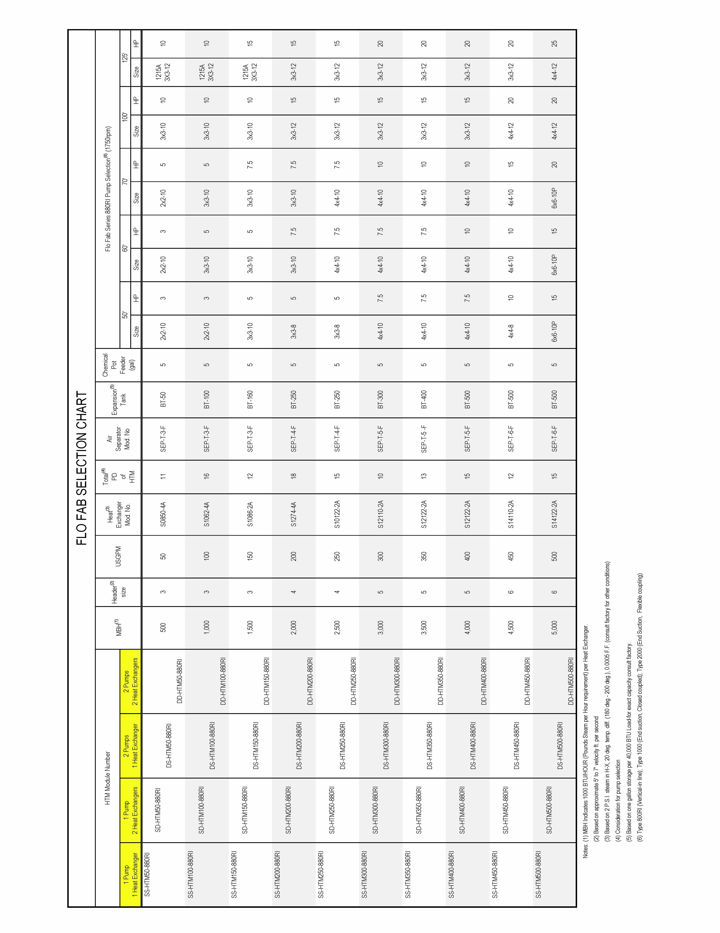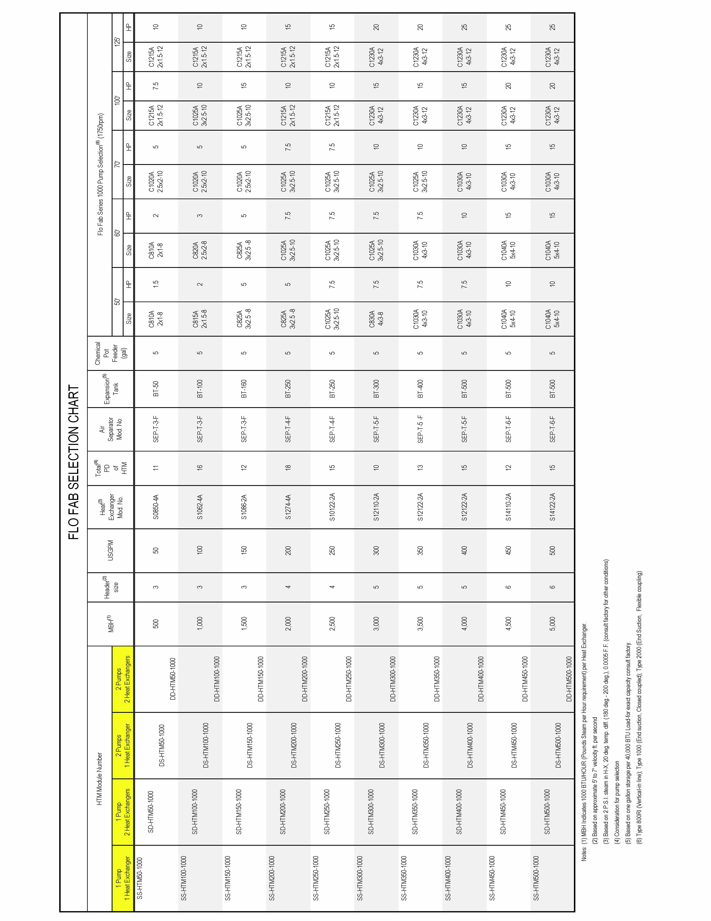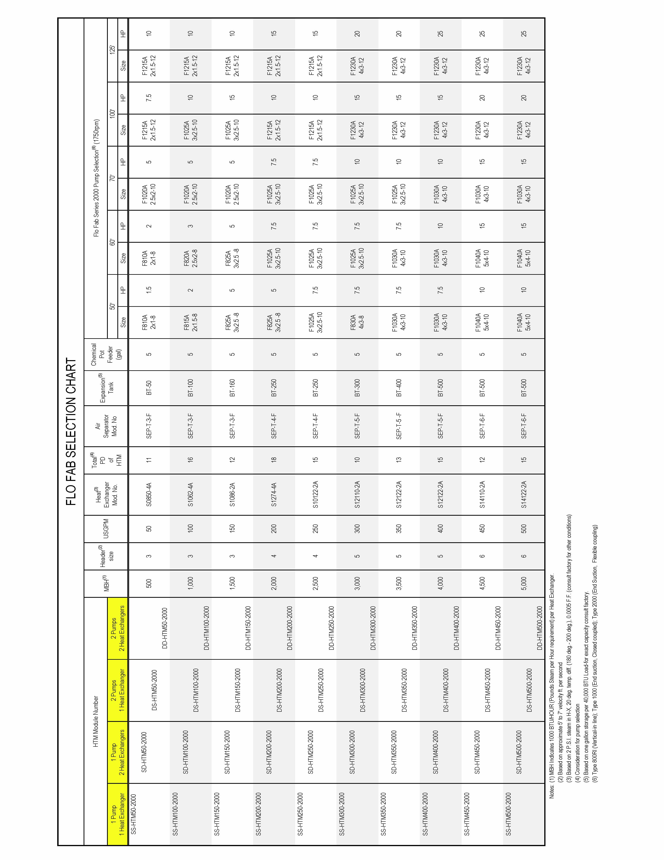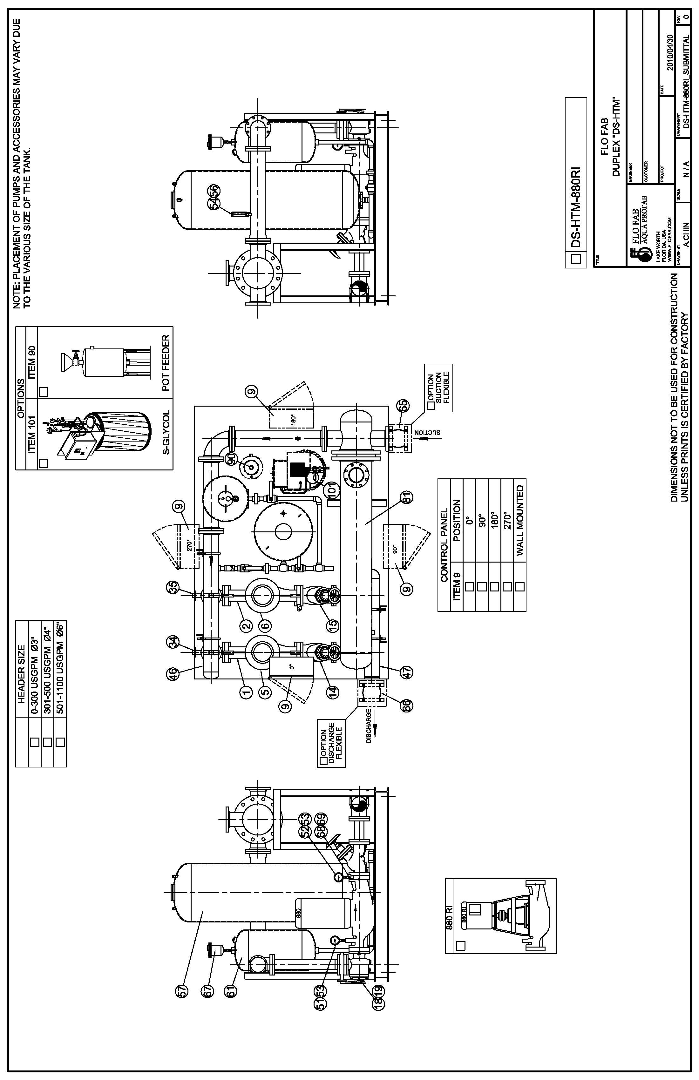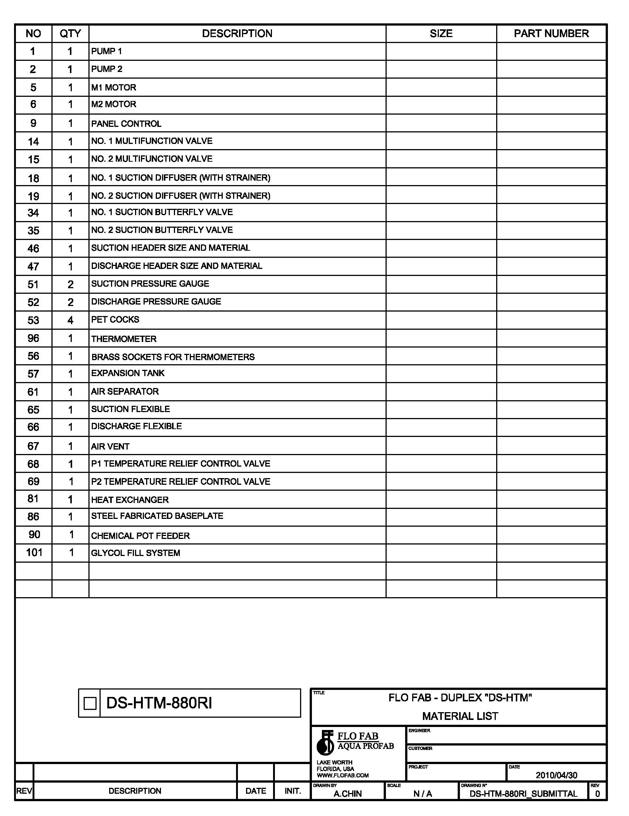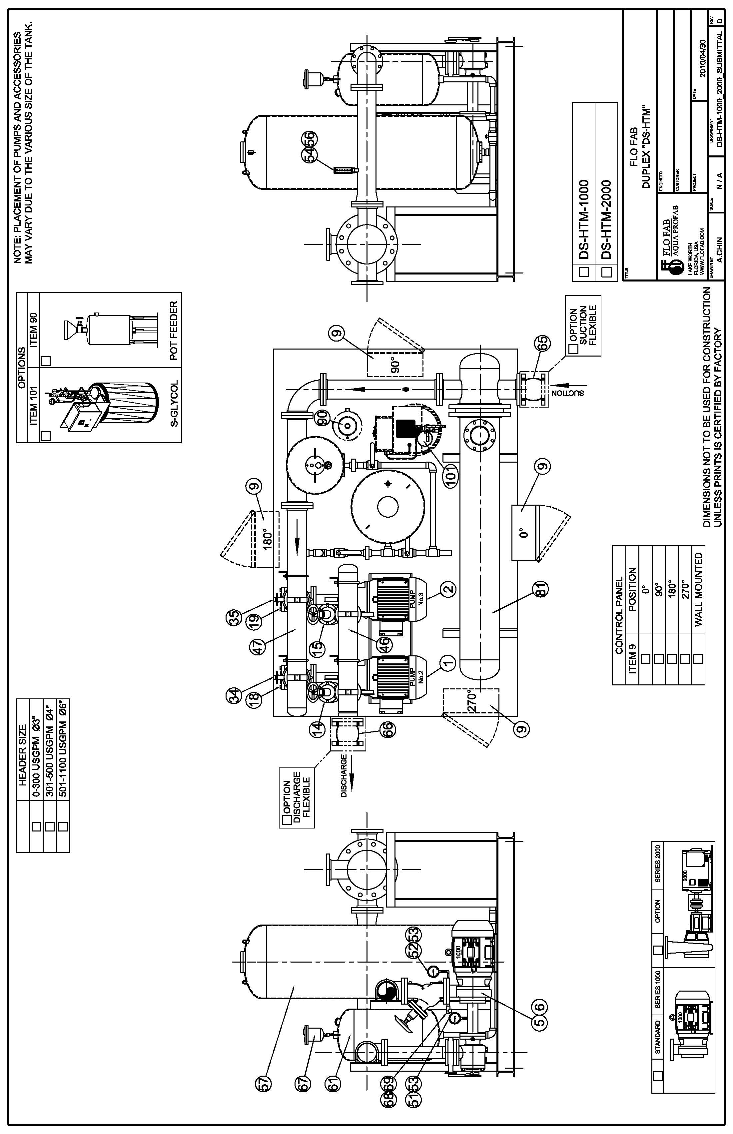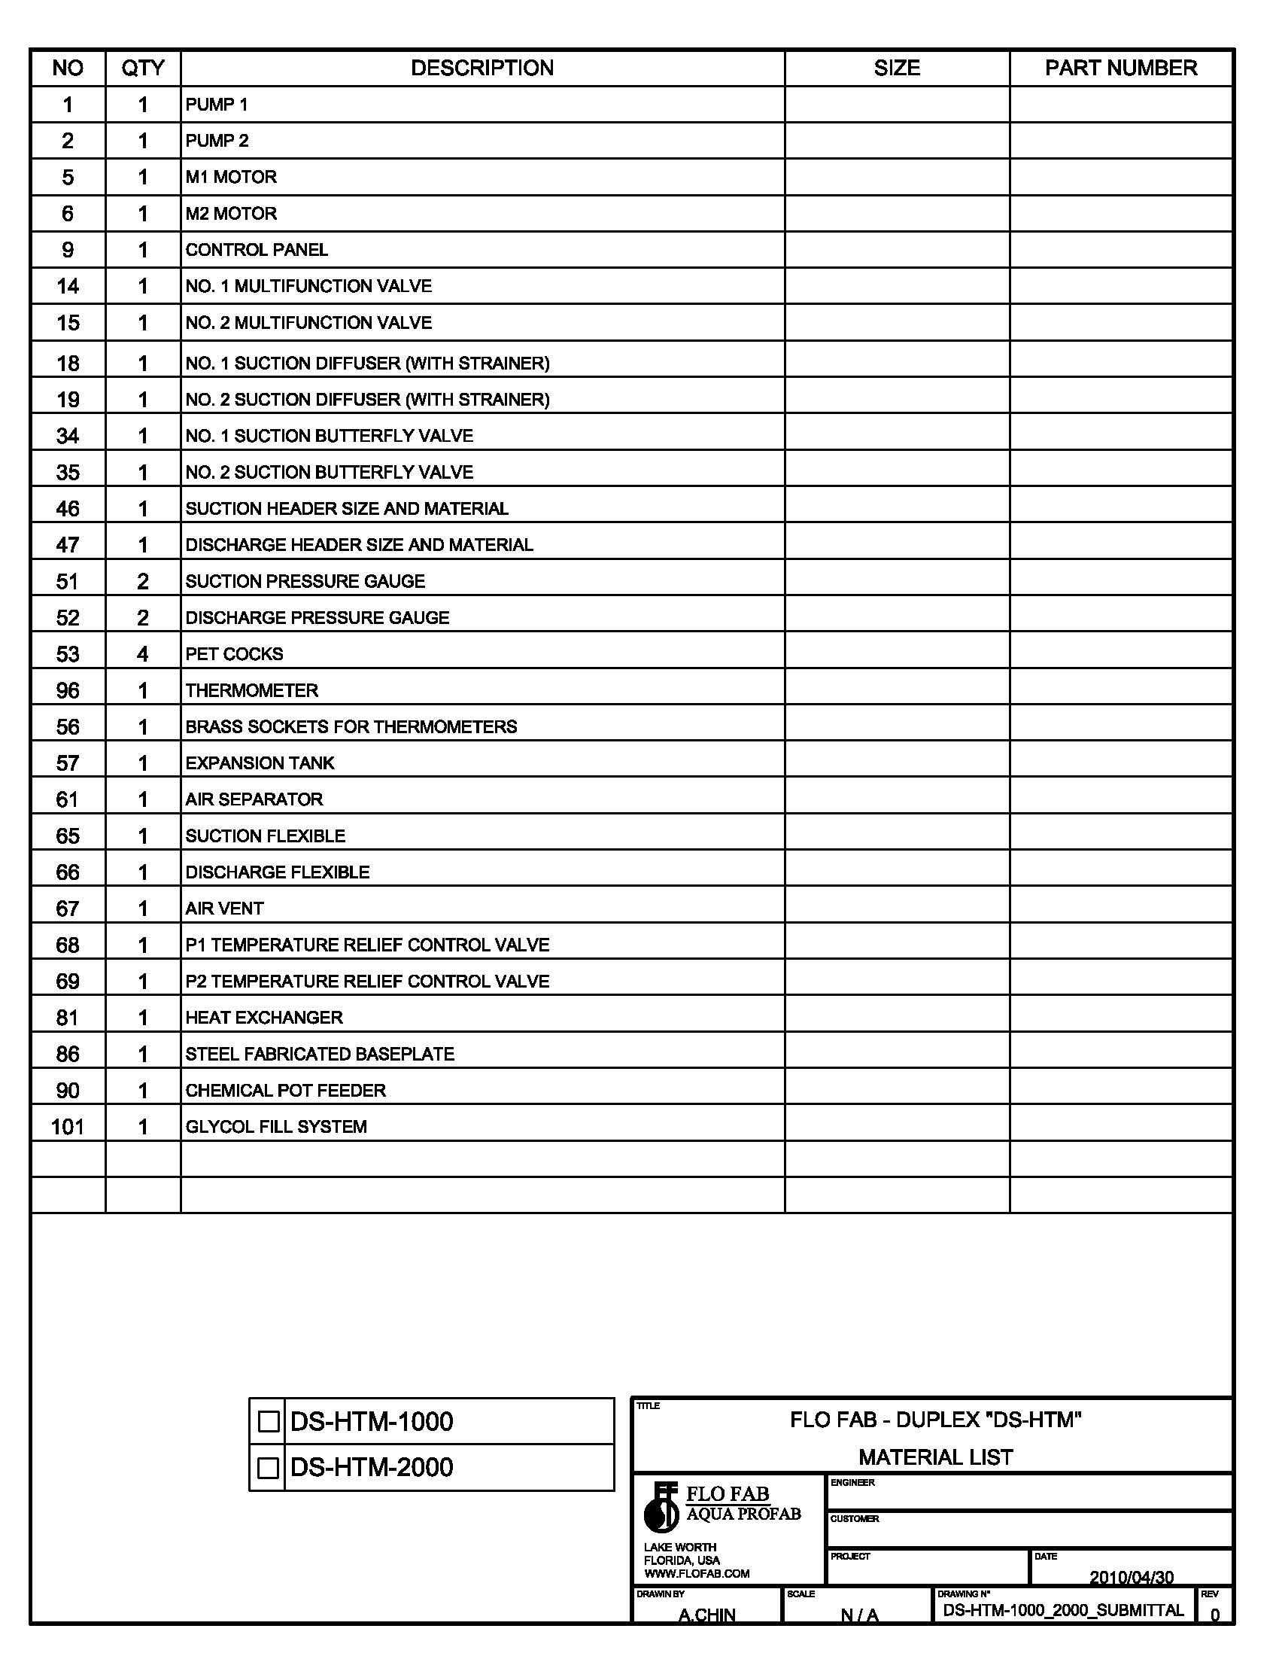

End of Section

