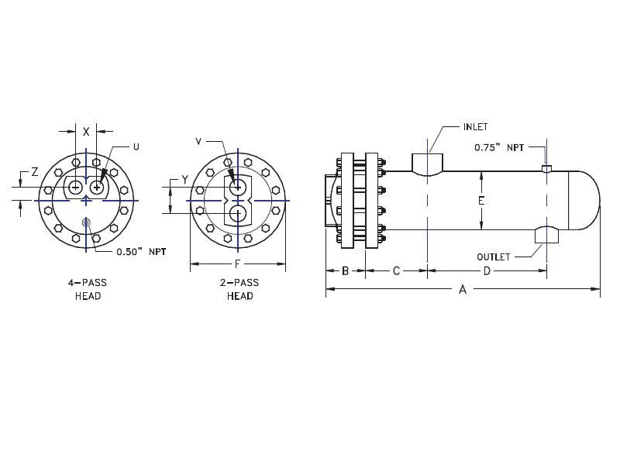

6.63

|  |  |  |  |  |  |  |  |  |  |  |  |  |  |  |
| --- | --- | --- | --- | --- | --- | --- | --- | --- | --- | --- | --- | --- | --- | --- |
|  | SIZE | DIMENSIONS | | | | | | -2  PASS | CONN  SIZE | -4  PASS | | CONN  SIZE | STEAM  IN | COND  OUT |
|  | A | B | C | D | F | LBS | Y | V | X | Z | U | NPT | NPT |
|  | W-0602 | 29.0 | 3.3 | 4.5 | 16 | 10.5 | 132 | 3.8 | 2 | 3.2 | 1.6 | 1.5 | 2 | 2 |
|  | W-0603 | 41.0 | 3.3 | 4.5 | 28 | 10.5 | 159 | 3.8 | 2 | 3.2 | 1.6 | 1.5 | 2 | 2 |
|  | W-0604 | 53.0 | 3.3 | 4.5 | 40 | 10.5 | 186 | 3.8 | 2 | 3.2 | 1.6 | 1.5 | 2 | 2 |
|  | W-0605 | 65.0 | 3.3 | 4.5 | 52 | 10.5 | 213 | 3.8 | 2 | 3.2 | 1.6 | 1.5 | 2 | 2 |
|  | W-0606 | 77.0 | 3.3 | 4.5 | 64 | 10.5 | 240 | 3.8 | 2 | 3.2 | 1.6 | 1.5 | 2 | 2 |
|  | W-0607 | 89.0 | 3.3 | 4.5 | 76 | 10.5 | 267 | 3.8 | 2 | 3.2 | 1.6 | 1.5 | 2 | 2 |
|  | W-0608 | 101.0 | 3.3 | 4.5 | 88 | 10.5 | 294 | 3.8 | 2 | 3.2 | 1.6 | 1.5 | 2 | 2 |
|  | W-0609 | 113.0 | 3.3 | 4.5 | 100 | 10.5 | 321 | 3.8 | 2 | 3.2 | 1.6 | 1.5 | 2 | 2 |
|  | W-0610 | 125.0 | 3.3 | 4.5 | 112 | 10.5 | 348 | 3.8 | 2 | 3.2 | 1.6 | 1.5 | 2 | 2 |
|  | W-0611 | 137.0 | 3.3 | 4.5 | 124 | 10.5 | 375 | 3.8 | 2 | 3.2 | 1.6 | 1.5 | 2 | 2 |
|  | W-0612 | 149.0 | 3.3 | 4.5 | 136 | 10.5 | 402 | 3.8 | 2 | 3.2 | 1.6 | 1.5 | 2 | 2 |
|  | DESIGN CONDITIONS | | | | | | | Notes:  Units fabricated and tested in accordance with ASME Section VIII Division 1.  Heat exchanger supports provided separately.  All dimensions + / - 0.125”. | | | | | | |
|  |  | | | TUBE SIDE | | SHELL SIDE | |
|  | DESIGN PRESSURE | | | 150 Psig | | 150 Psig | |
|  | TEST PRESSURE | | | 195 Psig | | 195 Psig | |
|  | DESIGN TEMPERATURE | | | 375 °F | | 375 °F | |
|  | MIN METAL: TEMPERATURE | | | 35 °F | | 35 °F | |

**Dimensional Data (inches)**