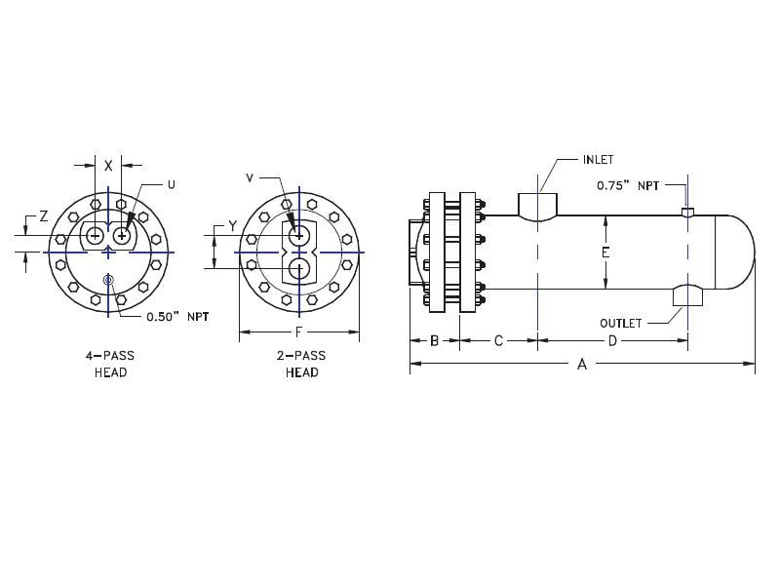

8.63

|  |  |  |  |  |  |  |  |  |  |  |  |  |  |  |
| --- | --- | --- | --- | --- | --- | --- | --- | --- | --- | --- | --- | --- | --- | --- |
|  | SIZE | DIMENSIONS | | | | | | -2  PASS | CONN  SIZE | -4  PASS | | CONN  SIZE | STEAM  IN | COND  OUT |
|  | A | B | C | D | F | LBS | Y | V | X | Z | U | NPT | NPT |
|  | W-0802 | 29.8 | 4.0 | 5.3 | 14.5 | 12.5 | 220 | 5.0 | 3 | 4.0 | 2.0 | 2 | 3 | 3 |
|  | W-0803 | 41.8 | 4.0 | 5.3 | 26.5 | 12.5 | 260 | 5.0 | 3 | 4.0 | 2.0 | 2 | 3 | 3 |
|  | W-0804 | 53.8 | 4.0 | 5.3 | 38.5 | 12.5 | 300 | 5.0 | 3 | 4.0 | 2.0 | 2 | 3 | 3 |
|  | W-0805 | 65.8 | 4.0 | 5.3 | 50.5 | 12.5 | 340 | 5.0 | 3 | 4.0 | 2.0 | 2 | 3 | 3 |
|  | W-0806 | 77.8 | 4.0 | 5.3 | 62.5 | 12.5 | 380 | 5.0 | 3 | 4.0 | 2.0 | 2 | 3 | 3 |
|  | W-0807 | 89.8 | 4.0 | 5.3 | 74.5 | 12.5 | 420 | 5.0 | 3 | 4.0 | 2.0 | 2 | 3 | 3 |
|  | W-0808 | 101.8 | 4.0 | 5.3 | 86.5 | 12.5 | 460 | 5.0 | 3 | 4.0 | 2.0 | 2 | 3 | 3 |
|  | W-0809 | 113.8 | 4.0 | 5.3 | 98.5 | 12.5 | 500 | 5.0 | 3 | 4.0 | 2.0 | 2 | 3 | 3 |
|  | W-0810 | 125.8 | 4.0 | 5.3 | 110.5 | 12.5 | 540 | 5.0 | 3 | 4.0 | 2.0 | 2 | 3 | 3 |
|  | W-0811 | 137.8 | 4.0 | 5.3 | 122.5 | 12.5 | 580 | 5.0 | 3 | 4.0 | 2.0 | 2 | 3 | 3 |
|  | W-0812 | 149.8 | 4.0 | 5.3 | 134.5 | 12.5 | 620 | 5.0 | 3 | 4.0 | 2.0 | 2 | 3 | 3 |
|  |  |  |  |  |  |  |  |  |  |  |  |  |  |  |
|  |  |  |  |  |  |  |  |  |  |  |  |  |  |  |
|  |  |  |  |  |  |  |  |  |  |  |  |  |  |  |
|  | DESIGN CONDITIONS | | | | | | | Notes:  Units fabricated and tested in accordance with ASME Section VIII Division 1.  Heat exchanger supports provided separately.  All dimensions + / - 0.125”. | | | | | | |
|  |  | | | TUBE SIDE | | SHELL SIDE | |
|  | DESIGN PRESSURE | | | 150 Psig | | 150 Psig | |
|  | TEST PRESSURE | | | 195 Psig | | 195 Psig | |
|  | DESIGN TEMPERATURE | | | 375 °F | | 375 °F | |
|  | MIN METAL: TEMPERATURE | | | 35 °F | | 35 °F | |

**Dimensional Data (inches)**