SHELL OUT

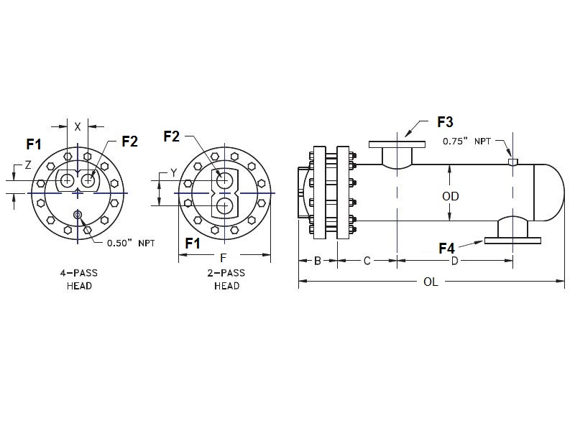

U

V

10.8

SHELL IN

A

|  |  |  |  |  |  |  |  |  |  |  |  |  |  |  |  |  |  |  |
| --- | --- | --- | --- | --- | --- | --- | --- | --- | --- | --- | --- | --- | --- | --- | --- | --- | --- | --- |
|  | SIZE | | DIMENSIONS | | | | | | | | -2  PASS | | CONN  SIZE | -4  PASS | | CONN  SIZE | SHELL  IN | SHELL  OUT |
|  | A | B | C | D | | F | LBS | | Y | | V | X | Z | U | ANSI | ANSI |
|  | W-1003 | | 43.3 | 4.9 | 5.8 | 25.5 | | 14.6 | 400 | | 5.9 | | 4 | 4.8 | 2.4 | 3 | 4 | 4 |
|  | W-1004 | | 55.3 | 4.9 | 5.8 | 37.5 | | 14.6 | 460 | | 5.9 | | 4 | 4.8 | 2.4 | 3 | 4 | 4 |
|  | W-1005 | | 67.3 | 4.9 | 5.8 | 49.5 | | 14.6 | 520 | | 5.9 | | 4 | 4.8 | 2.4 | 3 | 4 | 4 |
|  | W-1006 | | 79.3 | 4.9 | 5.8 | 61.5 | | 14.6 | 580 | | 5.9 | | 4 | 4.8 | 2.4 | 3 | 4 | 4 |
|  | W-1007 | | 91.3 | 4.9 | 5.8 | 73.5 | | 14.6 | 640 | | 5.9 | | 4 | 4.8 | 2.4 | 3 | 4 | 4 |
|  | W-1008 | | 103.3 | 4.9 | 5.8 | 85.5 | | 14.6 | 700 | | 5.9 | | 4 | 4.8 | 2.4 | 3 | 4 | 4 |
|  | W-1009 | | 115.3 | 4.9 | 5.8 | 97.5 | | 14.6 | 760 | | 5.9 | | 4 | 4.8 | 2.4 | 3 | 4 | 4 |
|  | W-1010 | | 127.3 | 4.9 | 5.8 | 109.5 | | 14.6 | 820 | | 5.9 | | 4 | 4.8 | 2.4 | 3 | 4 | 4 |
|  | W-1011 | | 139.3 | 4.9 | 5.8 | 121.5 | | 14.6 | 880 | | 5.9 | | 4 | 4.8 | 2.4 | 3 | 4 | 4 |
|  | W-1012 | | 151.3 | 4.9 | 5.8 | 133.5 | | 14.6 | 940 | | 5.9 | | 4 | 4.8 | 2.4 | 3 | 4 | 4 |
|  |  | DESIGN CONDITIONS | | | | | | | | | | Notes:  Units fabricated and tested in accordance with ASME Section VIII Division 1.  Heat exchanger supports provided separately.  All dimensions + / - 0.125”. | | | | | | | |
|  |  |  | | | | | TUBE SIDE | | | SHELL SIDE | |
|  |  | DESIGN PRESSURE | | | | | 125 Psig | | | 150 Psig | |
|  |  | TEST PRESSURE | | | | | 163 Psig | | | 195 Psig | |
|  |  | DESIGN TEMPERATURE | | | | | 375 °F | | | 375 °F | |
|  |  | MIN METAL: TEMPERATURE | | | | | 35 °F | | | 35 °F | |

**Dimensional Data (inches)**