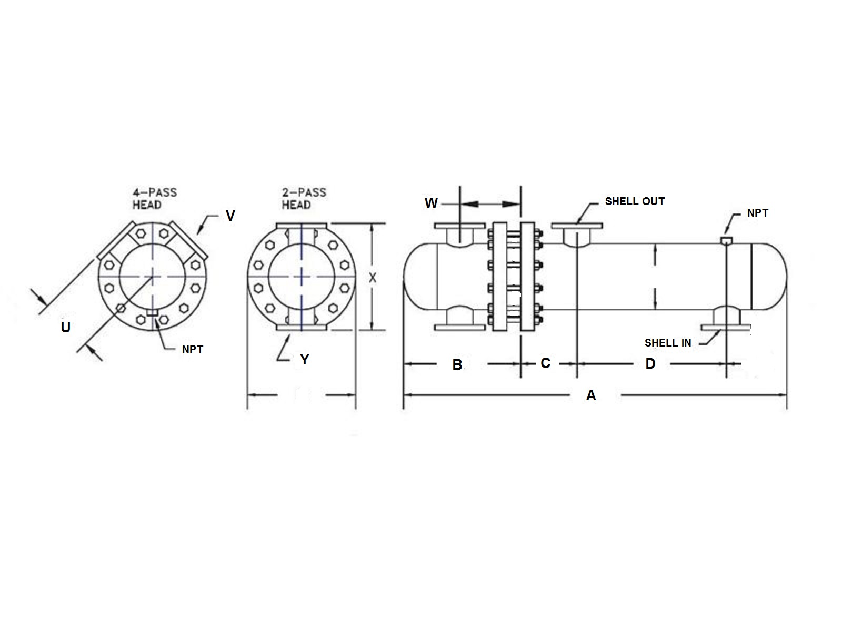

14

|  |  |  |  |  |  |  |  |  |  |  |  |  |  |  |
| --- | --- | --- | --- | --- | --- | --- | --- | --- | --- | --- | --- | --- | --- | --- |
|  | SIZE | DIMENSIONS | | | | | | -2  PASS | CONN  SIZE | -4  PASS | | CONN  SIZE | SHELL  IN | SHELL  OUT |
|  | A | B | C | D | W | LBS | X | Y | U |  | V | ANSI | ANSI |
|  | W-1403 | 54.4 | 16.4 | 7.0 | 23 | 8.1 | 695 | 23.0 | 6 | 11.5 |  | 4 | 6 | 6 |
|  | W-1404 | 66.4 | 16.4 | 7.0 | 35 | 8.1 | 815 | 23.0 | 6 | 11.5 |  | 4 | 6 | 6 |
|  | W-1405 | 78.4 | 16.4 | 7.0 | 47 | 8.1 | 935 | 23.0 | 6 | 11.5 |  | 4 | 6 | 6 |
|  | W-1406 | 90.4 | 16.4 | 7.0 | 59 | 8.1 | 1055 | 23.0 | 6 | 11.5 |  | 4 | 6 | 6 |
|  | W-1407 | 102.4 | 16.4 | 7.0 | 71 | 8.1 | 1180 | 23.0 | 6 | 11.5 |  | 4 | 6 | 6 |
|  | W-1408 | 114.4 | 16.4 | 7.0 | 83 | 8.1 | 1300 | 23.0 | 6 | 11.5 |  | 4 | 6 | 6 |
|  | W-1409 | 126.4 | 16.4 | 7.0 | 95 | 8.1 | 1420 | 23.0 | 6 | 11.5 |  | 4 | 6 | 6 |
|  | W-1410 | 138.4 | 16.4 | 7.0 | 107 | 8.1 | 1540 | 23.0 | 6 | 11.5 |  | 4 | 6 | 6 |
|  | W-1411 | 150.4 | 16.4 | 7.0 | 119 | 8.1 | 1661 | 23.0 | 6 | 11.5 |  | 4 | 6 | 6 |
|  | W-1412 | 162.4 | 16.4 | 7.0 | 131 | 8.1 | 1781 | 23.0 | 6 | 11.5 |  | 4 | 6 | 6 |
|  |  |  |  |  |  |  |  |  |  |  |  |  |  |  |
|  |  |  |  |  |  |  |  |  |  |  |  |  |  |  |
|  |  |  |  |  |  |  |  |  |  |  |  |  |  |  |
|  |  |  |  |  |  |  |  |  |  |  |  |  |  |  |
|  |  |  |  |  |  |  |  |  |  |  |  |  |  |  |
|  | DESIGN CONDITIONS | | | | | | | Notes:  Units fabricated and tested in accordance with ASME Section VIII Division 1.  Heat exchanger supports provided separately.  All dimensions + / - 0.125”. | | | | | | |
|  |  | | | TUBE SIDE | | SHELL SIDE | |
|  | DESIGN PRESSURE | | | 150 Psig | | 150 Psig | |
|  | TEST PRESSURE | | | 195 Psig | | 195 Psig | |
|  | DESIGN TEMPERATURE | | | 375 °F | | 375 °F | |
|  | MIN METAL: TEMPERATURE | | | 35 °F | | 35 °F | |

18