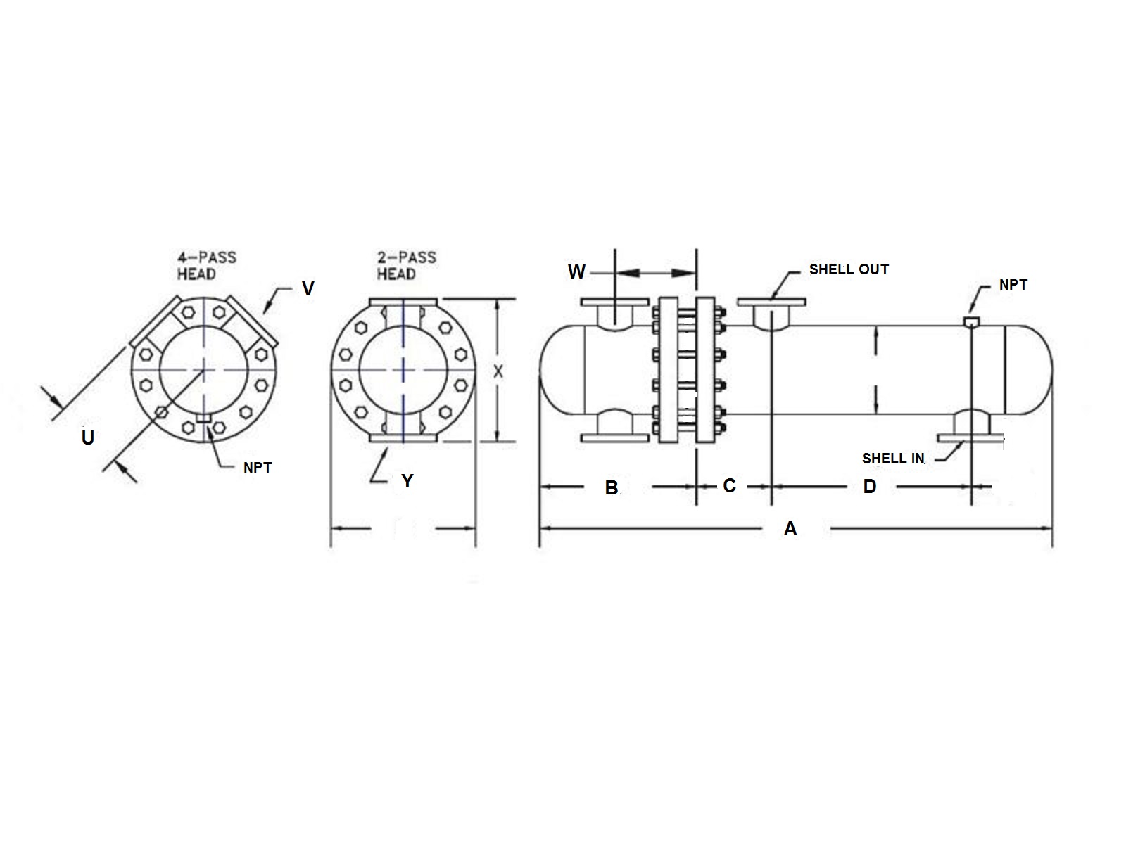

18

|  |  |  |  |  |  |  |  |  |  |  |  |  |  |  |
| --- | --- | --- | --- | --- | --- | --- | --- | --- | --- | --- | --- | --- | --- | --- |
|  | SIZE | DIMENSIONS | | | | | | -2  PASS | CONN  SIZE | -4  PASS | | CONN  SIZE | SHELL  IN | SHELL  OUT |
|  | A | B | C | D | W | LBS | X | Y | U |  | V | ANSI | ANSI |
|  | W-1803 | 56.4 | 18.4 | 7.3 | 21.5 | 8.9 | 1050 | 27.0 | 6 | 13.5 |  | 4 | 6 | 6 |
|  | W-1804 | 68.4 | 18.4 | 7.3 | 33.5 | 8.9 | 1250 | 27.0 | 6 | 13.5 |  | 4 | 6 | 6 |
|  | W-1805 | 80.4 | 18.4 | 7.3 | 45.5 | 8.9 | 1450 | 27.0 | 6 | 13.5 |  | 4 | 6 | 6 |
|  | W-1806 | 92.4 | 18.4 | 7.3 | 57.5 | 8.9 | 1650 | 27.0 | 6 | 13.5 |  | 4 | 6 | 6 |
|  | W-1807 | 104.4 | 18.4 | 7.3 | 69.5 | 8.9 | 1850 | 27.0 | 6 | 13.5 |  | 4 | 6 | 6 |
|  | W-1808 | 116.4 | 18.4 | 7.3 | 81.5 | 8.9 | 2050 | 27.0 | 6 | 13.5 |  | 4 | 6 | 6 |
|  | W-1809 | 128.4 | 18.4 | 7.3 | 93.5 | 8.9 | 2250 | 27.0 | 6 | 13.5 |  | 4 | 6 | 6 |
|  | W-1810 | 140.4 | 18.4 | 7.3 | 105.5 | 8.9 | 2450 | 27.0 | 6 | 13.5 |  | 4 | 6 | 6 |
|  | W-1811 | 152.4 | 18.4 | 7.3 | 117.5 | 8.9 | 2650 | 27.0 | 6 | 13.5 |  | 4 | 6 | 6 |
|  | W-1812 | 164.4 | 18.4 | 7.3 | 129.5 | 8.9 | 2850 | 27.0 | 6 | 13.5 |  | 4 | 6 | 6 |
|  | W-1813 | 176.4 | 18.4 | 7.3 | 141.5 | 8.9 | 3050 | 27.0 | 6 | 13.5 |  | 4 | 6 | 6 |
|  | W-1814 | 188.4 | 18.4 | 7.3 | 153.5 | 8.9 | 3250 | 27.0 | 6 | 13.5 |  | 4 | 6 | 6 |
|  | W-1815 | 200.4 | 18.4 | 7.3 | 165.5 | 8.9 | 3450 | 27.0 | 6 | 13.5 |  | 4 | 6 | 6 |
|  | DESIGN CONDITIONS | | | | | | | Notes:  Units fabricated and tested in accordance with ASME Section VIII Division 1.  Heat exchanger supports provided separately.  All dimensions + / - 0.125”. | | | | | | |
|  |  | | | TUBE SIDE | | SHELL SIDE | |
|  | DESIGN PRESSURE | | | 150 Psig | | 150 Psig | |
|  | TEST PRESSURE | | | 195 Psig | | 195 Psig | |
|  | DESIGN TEMPERATURE | | | 375 °F | | 375 °F | |
|  | MIN METAL: TEMPERATURE | | | 35 °F | | 35 °F | |

22