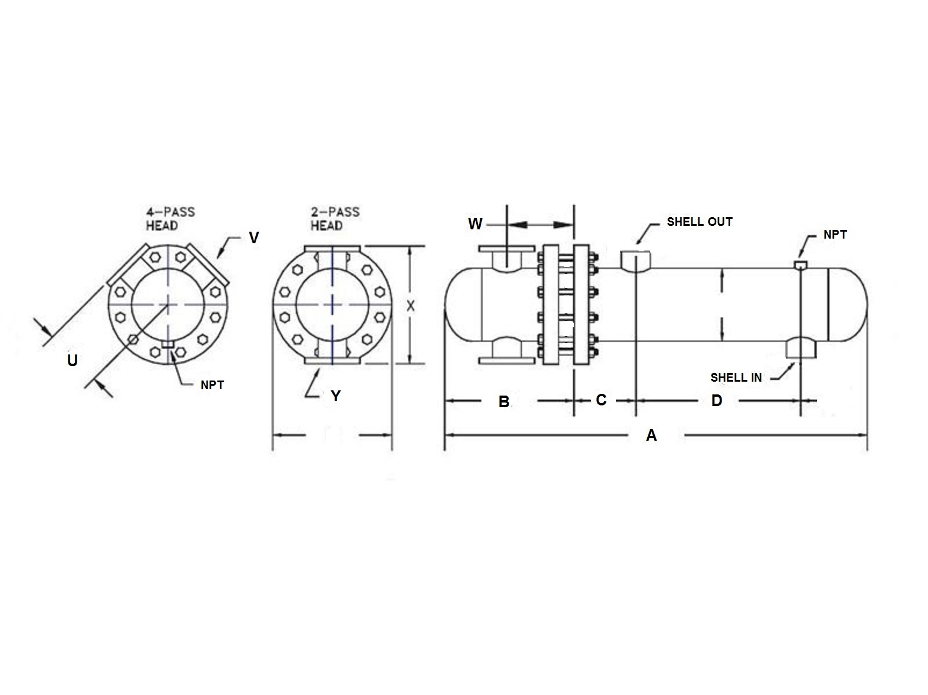

8.63

**F**

|  |  |  |  |  |  |  |  |  |  |  |  |  |  |  |
| --- | --- | --- | --- | --- | --- | --- | --- | --- | --- | --- | --- | --- | --- | --- |
|  | SIZE | DIMENSIONS | | | | | | -2  PASS | CONN  SIZE | -4  PASS | | CONN  SIZE | SHELL  IN | SHELL  OUT |
|  | A | B | C | D | F | LBS | X | Y | U |  | V | NPT | NPT |
|  | WF-0802 | 36.6 | 10.9 | 5.5 | 14.5 | 12.5 | 220 | 17.5 | 3 | 8.8 |  | 2 | 3 | 3 |
|  | WF-0803 | 48.6 | 10.9 | 5.5 | 26.5 | 12.5 | 260 | 17.5 | 3 | 8.8 |  | 2 | 3 | 3 |
|  | WF-0804 | 60.6 | 10.9 | 5.5 | 38.5 | 12.5 | 300 | 17.5 | 3 | 8.8 |  | 2 | 3 | 3 |
|  | WF-0805 | 72.6 | 10.9 | 5.5 | 50.5 | 12.5 | 340 | 17.5 | 3 | 8.8 |  | 2 | 3 | 3 |
|  | WF-0806 | 84.6 | 10.9 | 5.5 | 62.5 | 12.5 | 380 | 17.5 | 3 | 8.8 |  | 2 | 3 | 3 |
|  | WF-0807 | 96.6 | 10.9 | 5.5 | 74.5 | 12.5 | 420 | 17.5 | 3 | 8.8 |  | 2 | 3 | 3 |
|  | WF-0808 | 108.6 | 10.9 | 5.5 | 86.5 | 12.5 | 460 | 17.5 | 3 | 8.8 |  | 2 | 3 | 3 |
|  | WF-0809 | 120.6 | 10.9 | 5.5 | 98.5 | 12.5 | 500 | 17.5 | 3 | 8.8 |  | 2 | 3 | 3 |
|  | WF-0810 | 132.6 | 10.9 | 5.5 | 110.5 | 12.5 | 540 | 17.5 | 3 | 8.8 |  | 2 | 3 | 3 |
|  | WF-0811 | 144.6 | 10.9 | 5.5 | 122.5 | 12.5 | 580 | 17.5 | 3 | 8.8 |  | 2 | 3 | 3 |
|  | WF-0812 | 156.6 | 10.9 | 5.5 | 134.5 | 12.5 | 620 | 17.5 | 3 | 8.8 |  | 2 | 3 | 3 |
|  | DESIGN CONDITIONS | | | | | | | Notes:  Units fabricated and tested in accordance with ASME Section VIII Division 1.  Heat exchanger supports provided separately.  All dimensions + / - 0.125”. | | | | | | |
|  |  | | | TUBE SIDE | | SHELL SIDE | |
|  | DESIGN PRESSURE | | | 150 Psig | | 150 Psig | |
|  | TEST PRESSURE | | | 195 Psig | | 195 Psig | |
|  | DESIGN TEMPERATURE | | | 375 °F | | 375 °F | |
|  | MIN METAL: TEMPERATURE | | | 35 °F | | 35 °F | |

**Dimensional Data (inches)**